**Assignment 08 – Drupal 8 CMS Website (Basic Pages)**

**Instructions for completing template:**Replace **[bracketed red text]** with the requested information or screen capture.  
Replace **bracketed red text with black text** and then remove the brackets.  
Do not include full screen shot images, or full screen shots that are reduced in size. Use a snippet tool to capture parts of the screen and insert those images into the template.  
Do not remove tags from this template. Please answer all questions.  
**Please do not alter the formatting or delete parts of this template.**  
Assignment questions are not as detailed as activity questions.   
The assignment is where you demonstrate understanding of the material.

**Part A: Student Information**

1. **Student Name: Abel Marin [A01]**
2. **Class Designation: Remote [A02]**
3. **Student Contact Information: marinabe1416@gmail.com [A03]**
4. **What day and date did you start this assignment: Sunday March 1st, 2020 [A04]**

**Go back to the instructions and begin work on part B.**

**Part B: Create 1 Shared Web Host or PaaS Drupal 8 Website**

(1) Shared Web Host Drupal 8 CMS Site Information:

Shared Web Host Name: [SiteGround] [B01]  
cPanel URL: [Enter cPanel URL here] [B02] *Only for hosts with separate URL for cPanel  
cPanel Username: [amarin13@mail.depaul.edu] [B03]   
cPanel Password: [Dbeu!315] [B04]  
Domain Name: [abelm.sgedu.site] [B05]  
In Directory Name: [mod08assign08] [B06]  
Website Admin Username: [ajmarin] [B07]  
Website Admin Password: [yJ&qFJ2oLW] [B08]  
Database Name: [drup755] [B09]  
Table Prefix: [drz0_] [B10]  
Drupal 8 CMS Website URL: [http://abelm.sgedu.site/mod08assign08/] [Front End URL] [B11]

*Note: Please do not provide the Backend for B11 (above).*

-OR-

(2) Pantheon – Drupal 8 CMS Site Information:

**Assignment Website Site Name:** **[Site Name here] [B01]**

**WEBSITE Admin Username:** **[Admin Username here] [B02]**

**WEBSITE Admin Password:** **[Admin Password here] [B03]**

**Pantheon Frontend Website URL:** **[Frontend website URL here] [B04]**

**Note: Please do not provide the Backend URL fro B04 above.**

**Go back to the instructions and begin work on part C.  
  
Part C: Harden Shared Web Host or PaaS Drupal 8 Site**

1. SCREEN CAPTURE of the backend Admin toolbar > Configuration > Account settings, with the REGISTRATION AND CANCELATION section visible  
   **[A screenshot of a computer

   Description automatically generated] [C01]**
2. Screen capture of the Drupal 8 front-end website > User login page  
   **[A screenshot of a cell phone

   Description automatically generated] [C02]**

**Go back to the instructions and begin work on part D.**

**Part D: Answer Template Questions [D]**

1. Based on your experiences with finding, evaluating, installing WordPress plugins, how are Drupal 8 module selection best practices similar and different to those used for WordPress?  
   **[**Best practices for selecting Drupal 8 modules are very similar to best practices for selecting WordPress plugins. Similar to WordPress, you must check to see if the module is compatible with your version of Drupal. Also similar to WordPress, you should also check to see whether or not the module is actively maintained, whether or not it is being used by a large number of websites. A difference between the two is that Drupal doesn’t have the same type of reviews on Modules that WordPress has on plugins, although Drupal does have stars to show how many people have starred the module.**]**
2. Based on your experience with Drupal 8, what are Drupal’s differences from WordPress?  
   **[**The biggest difference I noticed between WordPress and Drupal is that Drupal you can easily make custom content types. With Drupal there is also the major difference that you can change both the admin and front-end themes instead of just front-end themes with WordPress. WordPress seems to be easier to add plugins than it is to add modules for Drupal. With WordPress you just download the plugin then activate it. With Drupal you must download from an outside website or file the module then install it again. It would probably take slightly longer to add modules to Drupal then to add plugins to WordPress. Drupal also seems to be more complex overall that WordPress.**]**
3. The steps required to perform before you can use a Drupal 8 contributed module to create content is find, install, permission, and configure.   
   Why is the permission step so important?   
   **[**The permission step ensures that anonymous users can see the content that is being created by granting permission to these users to view it.**]**
4. If you installed the FAQ module, then enabled it, created FAQ nodes. Testing the site as the site admin, the FAQ menu item is visible, and selecting displays an FAQ page. However, testing the site as an **anonymous user,** the FAQ main menu item is not visible and when you hard code the FAQ page URL, you get an “**Access denied, You are not authorized to access this page**” error.
   1. What is the cause of this error?  
      **[**This error pops up when you forget change the permissions so that anonymous users can View FAQ pages.**]**
   2. What steps do you take in the Drupal 8 admin backend to fix it?

**[**This can be easily fixed by going to Extend > FAQ > Frequently Asked Questions and clicking the permissions link that takes you to the permissions page. From here you just select that you want anonymous users to “View FAQ pages” and then press the Save permissions button.**]**

1. What is the purpose of Published check box on the Administration Basic page and Article content template pages?  
   **[**The published check box allows the page or article to be live on the web. If the published check box is deselected, then the content is not published.**]**
2. What are the steps to add a new user to a Drupal 8 site?  
   **[**1) log onto the website as an admin. 2) Go to the Person tab in the admin toolbar. 3) Press the add user button 4) Fill out the Add user page including the username, email, password, and especially the roles. 5) Press the Create new account button.**]**
3. What are the steps for finding, validating, installing, and activating a new DEFAULT Drupal 8 front-end client-facing theme?  
   **[**1) Go to Drupal.org and scroll to the bottom to find the Themes page under Download & Extend. 2) Once here you must then choose the version of Drupal you are using under Core compatibility and also any other the other search terms in order to specify which theme you want to find. 3) If the site follows best practices and it is a front-end theme then copy the link for the version you are using (usually the tar.gz with the 8.x release) 4) Go to the appearance tab on the Drupal backend and press the Install new theme button. 5) Paste the link into the Install from URL then press the install button. 6) Go back to the appearance tab in the back-end Drupal site and press “Install and set as default” the new theme that is now under the Uninstalled themes section.**]**
4. What are the steps for finding, validating, installing, and activating a new Drupal 8 back-end administration theme?

**[**1) Go to Drupal.org and scroll to the bottom to find the Themes page under Download & Extend. 2) Once here you must then choose the version of Drupal you are using under Core compatibility and also any other the other search terms in order to specify which theme you want to find. 3) If the site follows best practices and it is a back-end theme then copy the link for the version you are using (usually the tar.gz with the 8.x release) 4) Go to the appearance tab on the Drupal backend and press the Install new theme button. 5) Paste the link into the Install from URL then press the install button. 6) Go back to the appearance tab in the back-end Drupal site and press “Install” the new theme that is now under the Uninstalled themes section. 7) From here you would scroll down to the Administrative Theme section and select the theme from the select box. 8) Press the Save configuration button.**]**

**Go back to the instructions and begin work on part E.**

**Part E -** Extend the Shared (or PaaS) Drupal 8 Site with Core Modules

**1. SCREEN CAPTURE of the backend list of Admin toolbar > Extend with Core Contact visible  
] [E01]**

**2. SCREEN CAPTURE of the backend of Admin toolbar > Structure > Main navigation (edit menu)   
[**PLEASE MAKE SURE the Contact us menu item is visible**]   
] [E04]**

**] [E03]**

Part F - Extend the Shared (or PaaS) Drupal 8 Site with Contrib. Modules

**1. SCREEN CAPTURE of the backend list of Admin toolbar > Extend with FAQ section visible  
] [F01]**

**2. SCREEN CAPTURE of the backend list of Admin toolbar > Configuration > Content Authoring > Frequently Asked Questions, Categories TAB.   
] [F02]**

**3. SCREEN CAPTURE of the backend of Admin toolbar > Structure > Main navigation (edit menu)   
[**PLEASE MAKE SURE the FAQ menu item is visible**]   
] [F03]**

**4. SCREEN CAPTURE of the Editing the FAQ main navigation menu item  
] [F04]**

**] [F05]**

**Go back to the instructions and begin work on part G.**

Part G - Extend the Shared (or PaaS) Drupal 8 Site

**1. SCREEN CAPTURE of the backend list of Admin toolbar > Extend with Paragraphs section visible and all section entries fully expanded. See Example below:  
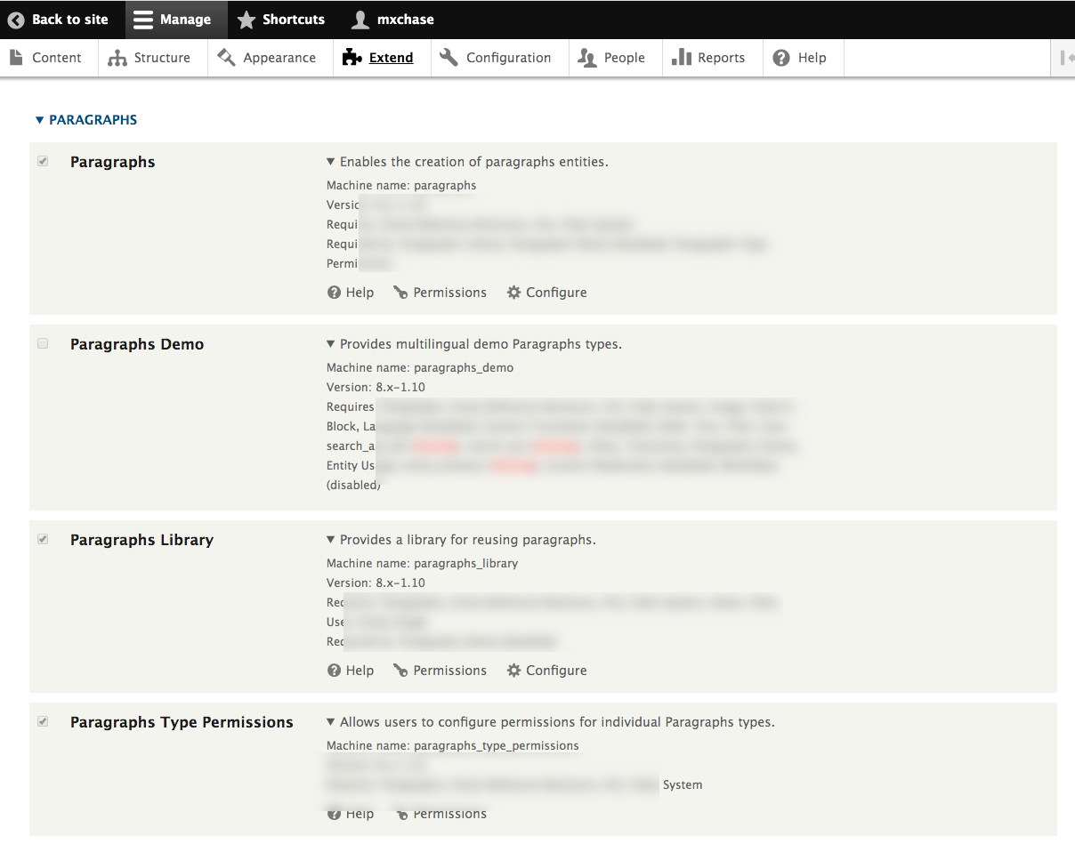  
] [G01]  
Go back to the instructions and begin work on Part H.**

**Part H - Codeanywhere account & Drupal 8 CMS site Info**

Codeanywhere account info:

1. **Codeanywhere account Username (email):** **[marinabe1416@gmail.com] [H01]**
2. **Codeanywhere account Password:** **[Dbeu!315] [H02]**

Codeanywhere Assignment 07 Drupal 8 Website Info:

1. **Drupal 8 CMS Website URL:** **[https://ajmassignment07-marinabe1416545968.codeanyapp.com] [H03]**
2. **Website Admin Username:** **[**ajmarin**] [H04]**
3. **Website Admin Password:** **[Dbeu!315!315] [H05]**

**Go back to the instructions and begin work on part I.**

**Part I -** Extend the Codeanywhere Drupal 8 Site **– Custom Module**

1. SCREEN CAPTURE of the Codeanywhere file system, showing the Modules folder expanded and the custom module folder fully expanded

**] [I01]**

1. SCREEN CAPTURE of info.yml file

**] [I02]**

1. SCREEN CAPTURE of routing.yml file

**] [I03]**

1. SCREEN CAPTURE of Control file  
   **[A screenshot of a cell phone

   Description automatically generated] [I04]**
2. While logged into the Drupal 8 site, Access the custom plugin by adding its path to the end of the site URL then take a SCREEN CAPTURE of Drupal site  
   **[A screenshot of a cell phone

   Description automatically generated] [I05]**

**Part J – Assignment Wrap up: (REQUIRED)**

Answers to questions 1-3 are required to receive points for this section.

1. **Did you work with a tutor or volunteer on this assignment? [J01]  
   [No]**
2. **Did you have any problem or issues completing this assignment? [J02]  
   This is not an optional question.   
   [No]**
3. **If you answered yes to question 03, did you contact the instructor for help? [J03]  
    [I answered no to question 03]**
4. **If you answered yes to question 03, please elaborate and be specific about the issues or problems you had (other than time management)  
   If you had trouble with a specific section, part, or question, please identify it by number and explain what you did not understand or had problems with in the box below. [J04]   
   *Required if you answered Yes to #2 – Otherwise optional  
   [Problem details or list of details here]**